COVID-19 Safety Plan
Mission Tennis Club

Introduction:

Mission Tennis Club (MTC) agrees to abide by all municipal, provincial, and federal guidelines surrounding the safety of our tennis players in relation to the COVID-19 pandemic.

Outlined in this file are five separate documents which support our commitment to a safe return to outdoor tennis play:

1. Safety Plan
2. Participant Agreement
3. Waiver
4. Poster
5. Symptoms/Conditions Check

- 1 -
We have identified the risks of tennis play applicable to our Club:
- Distance Amongst Players: Low risk
a) Court dimensions: Given the large dimensions of a tennis court, we can ensure all players will be 2 meters or greater apart during all activities; e.g. practice, warm-up, play, water-breaks, etc. The following images illustrate the sample distance amongst players:
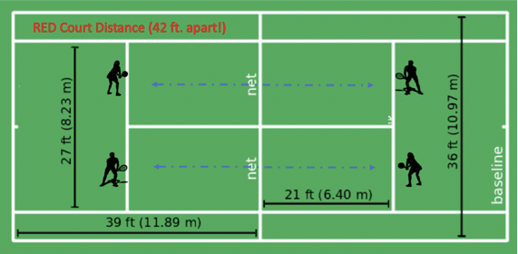

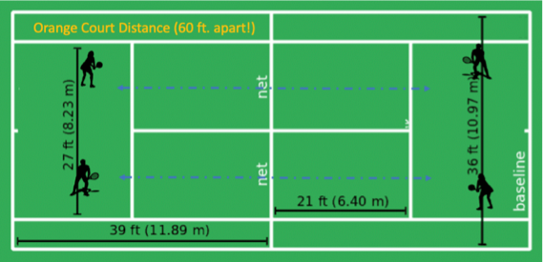

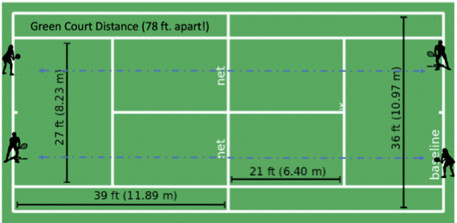

- Physical contact: All players will agree to no physical contact with other participants including high-fives or fist bumps, as written in our Participant Agreement.
- Entering and exiting courts: The main gate to the courts has been removed, allowing for a wide entry and exit point with no touch points required. Players may not enter the courts until someone exits; maintaining a minimum of 2 meters distance at all times. Players will be reminded of this requirement with posted signage. A hand sanitization station will be located at the entry point and will promote hand sanitization before and after play.
- People waiting to play: Players are only able to approach the courts when there is adequate court space to begin playing. There shall be no socializing outside the courts by MTC members.
- Movement between play: When changing ends during a match, participants will do so in a clockwise fashion, avoiding any close physical contact with the opposing team.

- 2 -
- Distance between players during play: When playing doubles, players must communicate with teammates their plan to maintain distance between themselves. This could include calling shots and agreeing to play front/back or side/side using court lines as barriers.
- Common areas: No common areas exist at the Centennial Park courts where our activities take place.
- Number of Participants: Low risk
- To ensure ample distance amongst players, we will limit the number of participants to ONLY 4 PLAYERS per full size tennis court. This limits our total number of participants to 16 at any given time.
- Spectators: No additional people will be permitted on courts except players participating in a game. See also “1. d)” above.
- Touch surfaces: Low risk
- Tennis balls: To eliminate any risk, each player will use their own, clearly-marked balls and whomever is serving, uses their own balls. Each player will return other’s balls using their racquet to avoid touching someone else’s balls. This also applies to returning balls that may have crossed over from another court.
- Tennis racquets: Players have their own racquets which they bring for their own use and do NOT exchange racquets amongst themselves.
- Other player equipment: Player’s tennis bags will be placed at least 6 meters from other player’s tennis bags in order to facilitate safe distancing.
- Court benches: Only one person will be allowed on a bench at one time unless players are from the same household. Top surfaces of benches will be sanitized after each use by the player who has used the bench. Spray disinfectant and one-time-use paper towels plus garbage cans will be provided for this purpose.
- Keeping score: No score cards will be in use. Participants will keep score verbally.
- Hand hygiene: Participants are encouraged to arrive at the courts with clean hands and to bring, and frequently use, personal hand sanitizer. In addition, hand sanitization stations will be provided by the Club at each of the four benches as well as at the entry gate.
- Eating and drinking: No food or beverages, except for hydration, will be permitted on the courts. No sharing of water bottles (or the like) will be permitted. Bottles will be kept separate from each other in order to limit congregating of participants while rehydrating.
4. Participants who may be ill:
a) Prior risk assessment: Before each session of play, participants must self-assess their risk factors for COVID-19 infection. Symptoms, isolation orders from Public Health, travel history review, and COVID-19 case contact assessment will be part of the Participation Agreement.

- 3 -
b) Emerging risk: Participants agree to monitor self and playing partner for emerging symptoms during play. If symptoms develop at any time, participants must agree to immediately leave the courts and follow up with Public Health. If symptoms are severe, 9-1-1 will be called and surfaces that the ill participant has come into contact with will be cleaned and disinfected.
- Contact tracing: Each player must sign in before entering courts and provide their name, phone number, and email address for the purposes of contact tracing, should it become necessary. The Club will provide an appropriately-labelled container of clean pens for single use only and an appropriately-labelled container for used pens. Sign-in documents will be retained for a period of no less than one month.
d) First Aid: If first aid is required to be administered during an activity, whomever attends to the injured individual must first put on a mask and gloves. A First-Aid kit will be on hand during club hours.
A Club coordinator should:
- Stop the activity for all participants
- Gather information to determine whether the issue is COVID-19-related or another type of medical incident.

If not COVID-19-related:
- Ask if the participant can self-treat with assistance. If so, provide them with the supplies they need while maintaining a physical distance of 2 meters.
- If direct care is needed, put on your mask and gloves.
- If the participant is unresponsive or a serious injury is involved, call 9-1-1 immediately.

If COVID-19 is suspected:
- Member is required to leave the premises immediately to self-isolate and contact the Provincial Public Health Office or call 8-1-1.

** Used masks and gloves must be disposed of after use and proper hand hygiene must be performed; e.g. soap and water and/or hand sanitizer.

- 4 -

We have a comprehensive plan in place for ensuring participants are aware of, and follow, our Safety Plan:
- Executive members of our Club have been involved in the creation of this document and support the Plan.
- Mission Tennis Club’s COVID-19 Safety Plan will be emailed to each member of our Club. Before being permitted to play as a Club member, players must acknowledge they have read and understood the Plan and agree to follow all rules outlined in the Participant Agreement. This acknowledgement will be in the form of a return email to the Club’s executive, stating as such.
- During all Club times, Safety Posters will be posted at the entrance of the courts, outlining key points of our Plan as a reminder to all participants before play begins.
- During all Club times, at least one Club coordinator will be at the courts to ensure rules are being followed properly, and will also organize who goes onto each court when the preceding match has been completed.

We will take steps to update our policies and procedures when needed:
  - Executive members will check in weekly via email to identify policies and procedures that have been effective and those that need modifying.
  - Participants have been informed to notify an executive member with any health or safety concerns. Executive names, emails, and phone numbers have been disseminated to all members.

- 5 -
Participant Agreement
- I agree to always be a minimum of 2 meters apart from all other participants during all activities; e.g. entering courts, practice, warm-up, play, water-breaks, exiting courts, etc.. This includes no physical contact between other participants such as high-fives or fist bumps.
- I agree to only approach the courts when there is adequate court space to begin playing; i.e. less than 16 players.
- I agree to not socialize outside of the courts.
- I agree that when changing sides during a match, I will do so in a clockwise fashion, avoiding any close physical contact with my teammate or the opposing team.
- I agree that when playing doubles, I will communicate with my teammate about our plan to maintain distance between ourselves during play. This could include calling shots and agreeing to play front/back or side/side using court lines as barriers.
- I agree to limit the number of players to only 4 per tennis court.
- I agree to not enter courts unless I am participating in a game.
- I agree to not bring any additional people onto the courts who are not participating in play.
- I agree to touchless pick up of balls by using my racquet.
- I agree to only handle my own tennis balls, which I have clearly identified.
- I agree to bring my own racquet for use and to not exchange racquets with other participants.
- I agree to respect the limit of one participant per bench at a time. After using a bench, I agree to sanitize its top surface with the disinfectant and paper towels provided, and to discard the used paper towel in the appropriate receptacle after a one-time-use.
- I agree to not use score cards but instead, to keep score verbally.
- I agree to arrive for play with clean hands. I acknowledge that it is encouraged to bring and frequently use personal hand sanitizer. If personal hand sanitizer is forgotten, I am aware the Club has hand sanitization stations at each of the four benches as well as at the entry/exit gate.
- I agree to not bring any food or beverages except water onto the courts. I agree to keep my water bottle separate from other bottles in order to limit congregating of participants while hydrating.
- I agree to assess my personal risk for COVD-19 infection before every participation in Club activities.
- I acknowledge that if I am able to answer YES to any of the following questions, I will be prohibited from participating in Mission Tennis Club activities at this time:
  - Have you had symptoms of COVID-19 in the last 10 days? Symptoms include fever, chills, new or worsening cough, shortness of breath, sore throat, new muscle aches, headache.
  - Have you been directed by Public Health to self-isolate?
  - Have you arrived from outside Canada in the last 14 days?
  - Have you had contact with a confirmed COVID-19 case in the last 14 days?

- I agree to monitor myself and playing partner for emerging symptoms of COVID-19 during play. If symptoms develop at any time, I agree to leave the courts immediately and follow up with Provincial Public Health authorities.
- I agree to sign in before entering courts and provide my name, phone number, and email address for the purposes of contact tracing, should it become necessary.
- I agree to review the displayed signage before every session of play.
- I understand that if at any time participants are not observing the Safety Plan, they will not be permitted to play.
- I acknowledge that there will be a Mission Tennis Club coordinator at the courts at all times during scheduled play time. The coordinator will ensure rules are being followed as well as organize who goes onto each court when the preceding match has been completed.
- I agree to notify an executive member with any health and safety concerns.
- I agree to email the Mission Tennis Club executive, confirming that I have read this document and that I agree to each statement contained within.
- I acknowledge that permission to play with the Mission Tennis Club will not be granted until after the executive has received my declaration via email.

Mission Tennis Club Executive Team:

Mark & Val Gervais
Markandval73@gmail.com
604-826-2586

Ted Bryde
tedbryde@telus.net
604-826-7606

Terry Johnston
tljohnston99@gmail.com
604-855-6483

Cameron Van Oort
cvanoor@uwo.ca
604-841-2241

Jeff Waite
jeffwaite67@gmail.com
778-245-3071

Rose Sapizak
sapizak@telus.net
604-614-0809

Waiver of Release

I DO HEREBY RELEASE Mission Tennis Club and District of Mission and its directors, officers, employees, sponsors, independent contractors and agents from all liability, and DO HEREBY WAIVE as against Mission Tennis Club and District of Mission and its directors, officers, employees, sponsors, independent contractors and agents all recourses, proceedings, claims, and causes of action of any kind whatsoever, in respect of any and all personal injuries or property losses which I may suffer arising out of, or connected with my preparation for, or participation in, tennis; notwithstanding that such injuries or losses may have been caused solely or partly by the negligence or breach of duty of Mission Tennis Club and District of Mission, or any of their directors, officers, employees, sponsors, independent contractors or agents.

